**Experiment No. 10**

1. **Aim/Overview of the practical:**

Create a virtual machine and configure IIS server on Azure.

1. **Code for practical:**

* Open Azure portal and go to ***resources>windows server 2019 Datacenter.***
* Select resource group and enter details for virtual machine.

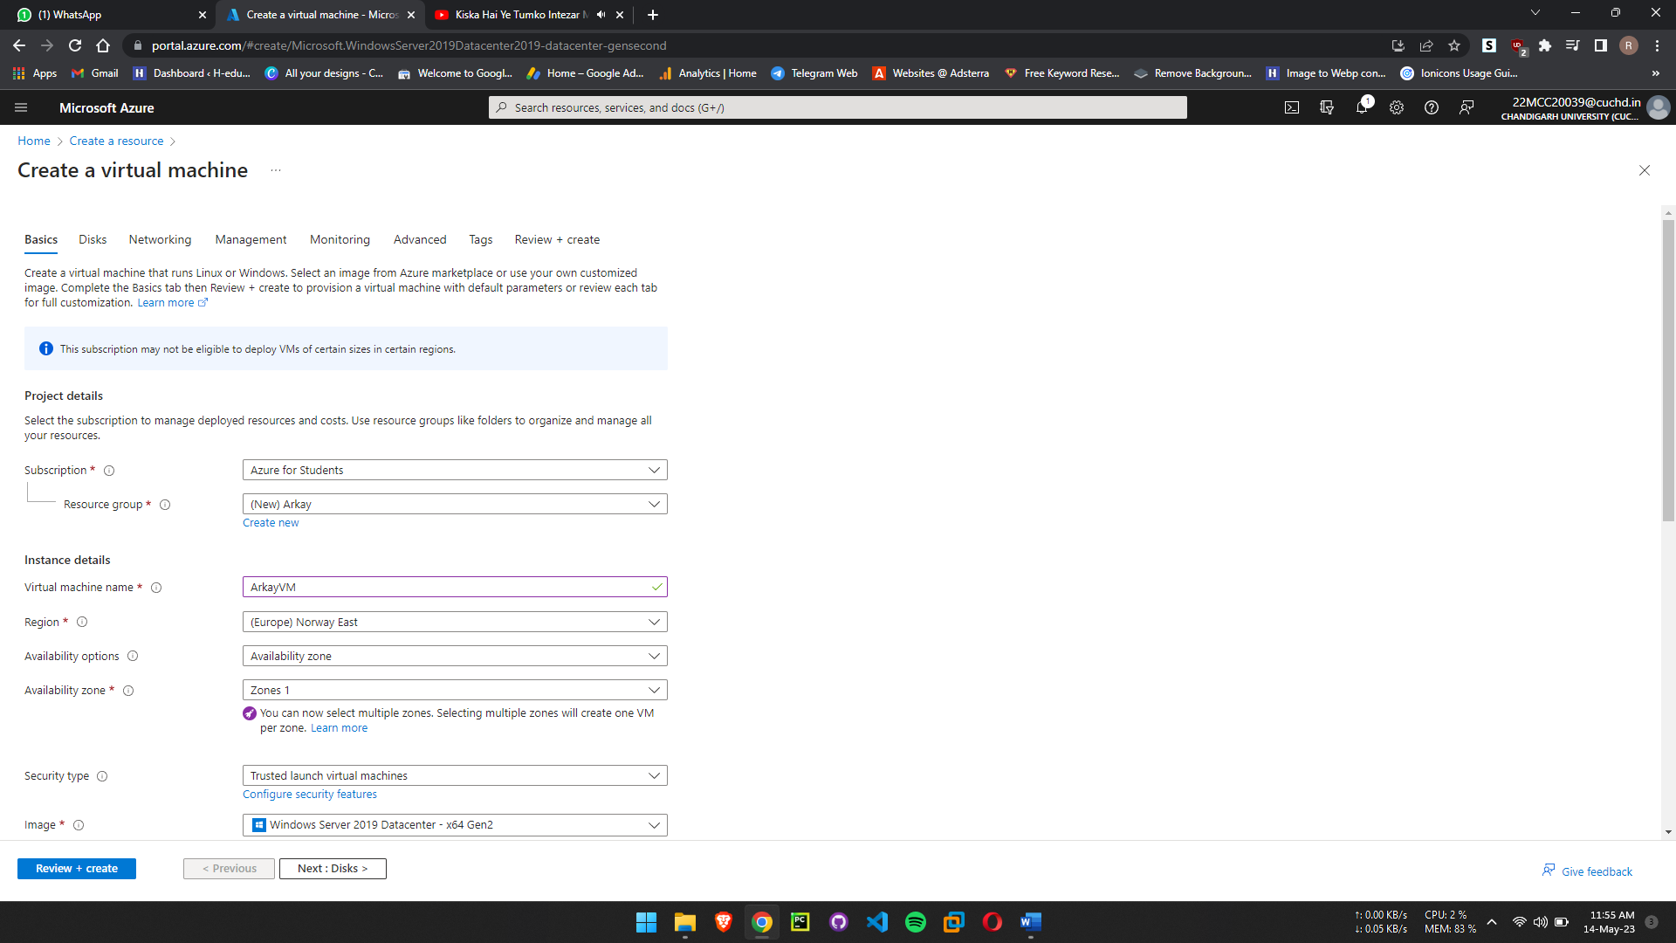

* Enter username and password for VM.

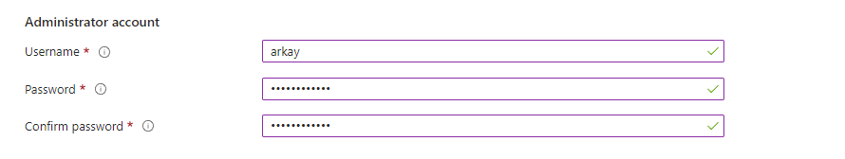

* Select inbounds ports to ***HTTP (80), HTTPS (443), RDP (3389)***.
* Click on next.
* Select OS disk type to ***HDD standard***.
* Now click on Tags options and enter name of your VM.

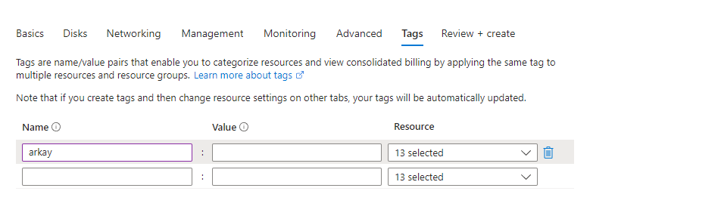

* Click on Reviw + Create button.
* Virtual machine will be deployed within minutes.
* Now to access the VM, press ***Win + R*** to open run.
* Type ***mstsc*** in run command. Enter IP address from your resource.

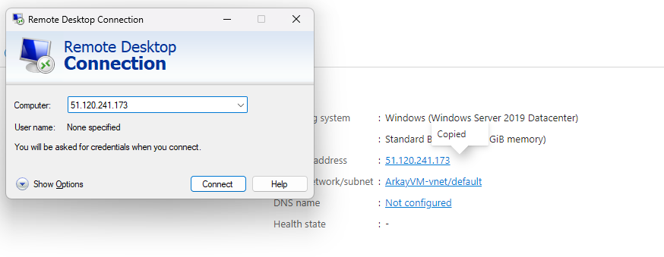

* A popup will open click on use another account and enter username and password.
* Click on connect button and your VM will start.

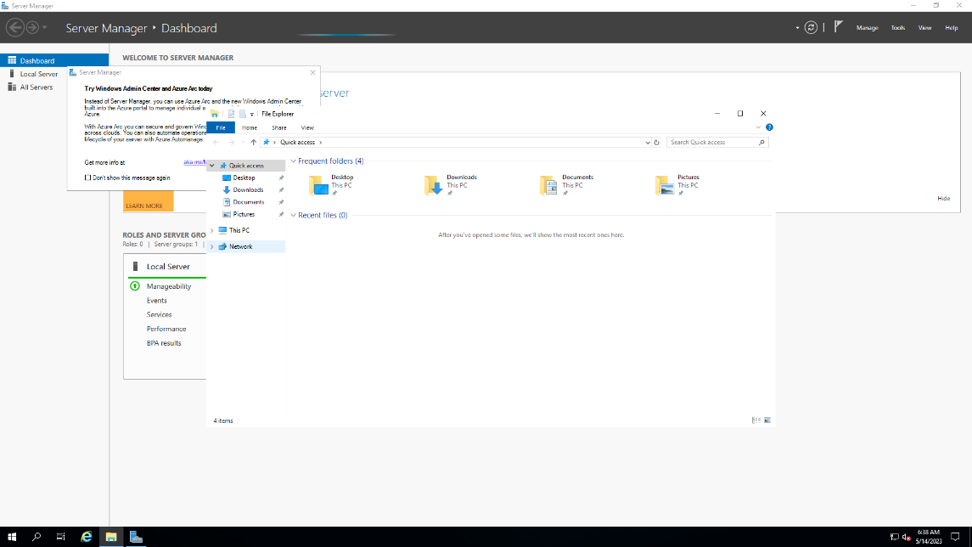

* Now you can use your VM easily.

**************************************** **THE END** ***********************************************